Garden Ridge Preschool
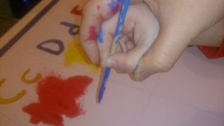

Sept 2-4, 2026
Closed Mon. Sept 7 (Labor Day)
Read a book Day Sept 6

All About Me- Look and See
Literacy | German/ASL | Math | Science |  | Social Studies | Art | Music and  Movement | Small Group  Activities
Calendar (days of the week, date, months of the year), and Weather  Word Awareness / Book Concepts  Concepts words for the month:  Friend, fun, laugh, play, together, class, give, help, listen, share, school. | Visit with Miss Eva  What is ASL? Introduction  Star Spangled Banner  Video story | We will introduce math areas in the classrooms.  Module 1-A will start next week.  Module 1 is counting to five. | How the heart pumps |  | What makes me alive?  Living and non-living  Sorting. | First Day Art  Grand Parents  Day Art  Sept Month  Poem Art | Name Game, Hearing/Seeing Sound  Circle time song.  Days of the week  Months of the year. | Cutting  Exercises  HWT  Individual  Reading
Poem:
Red, Yellow, Green, and Brown,
Leaves are falling on the ground.
We pile them up, oh so high,
And jump right in my friend and I

Books for this week:
School’s First Day of School by Adam Rex (GRP)
Brave Little Raccoon by Erica Wolf (GRP)
No Two Alike by Keith Baker (GRP)
The Kissing Hand by Audrey Penn (GRP)
Only One You by Linda Kranz (GRP)
Size by Felicia Law (GRP)
B. Bear and Lolly Off to School by AA Livingston (GRP)
Froggy Goes to School by Jonathan London (GRP)
How Nature Works by David Burnie (for living and non-living SS) (GRP)

