Garden Ridge Preschool
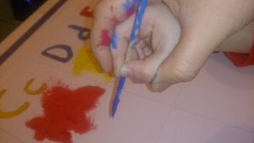

June 8-12, 2026
World Ocean Day June 8
Father’s Day June 14
Make it Move: Flight
Literacy | German/  ASL | Math | Science |  | Social Studies | Art | Music and  Movement | Small Group  Activities
Calendar and Weather  Literacy: Letter Zz  Concept Words:  Float, buoyancy, sink, build, carry, crane, dig, dump, truck, hole, down, fast, slow, start, stop, up, lift, more, pull, push, roll, weight, balloon, blow, kite, pinwheel, sailboat, umbrella | German: “Das Auf und ab der Schwerkraft“ Airplanes  ASL: Classifiers and mouth sounds.  . | Module 5-F  Duplicating and extending patterns | Friction, mass, velocity, build a catapult/  Flight Experiment  Disc launcher  -length  Spinners  -height  Ball/motion |  | World Ocean Day-  Labeling a globe are- How much of our world is water? | Plain/ rockets art | London Bridge is falling down.  Simon Says (Motion words)  Motion song | Cutting  Exercises  HWT  Individual  Reading
Poem:
Here is a nest for a robin,
And here is a hive for a bee.
Here is a hole for a bunny,
And here is a house for me.

Books for this week:
Violet the Pilot by Steve Breen (GRP)
Amelia’s Fantastic Flight by Rose Bursik (GRP)
Flight School by Lita Judge (GRP)
North, South, East, and West by Margaret Brown (GRP)
Only One You by Linda Kranz (GRP)
Yah, You by Sandra Boyton (GRP) Reflections of a Father’s Love by Brad Dawson (GRP) What Mary Jo Shared by Janice Udry (GRP)

