Garden Ridge Preschool

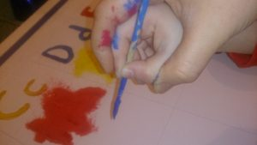



June 9-13, 2023

Father’s Day June 15

Make it Move: Flight

|  |  |  |  |  |  |  |  |  |  |
| --- | --- | --- | --- | --- | --- | --- | --- | --- | --- |
| Literacy | German/  ASL | Math | Science | | Social Studies | Art | Music and  Movement | Small Group  Activities | |
| Calendar and Weather  Literacy: Letter Zz  Concept Words:  Float, buoyancy, sink, build, carry, crane, dig, dump, truck, hole, down, fast, slow, start, stop, up, lift, more, pull, push, roll, weight, balloon, blow, kite, pinwheel, sailboat, umbrella | German: Airplanes and trains  ASL: Try to tell a story with no words- play charades. | Module 5-F  Duplicating and extending patterns | Friction, mass, velocity, build a catapult/  Flight experiment:  Disc launcher  -length  Spinners  -height  Ball/motion | | Mapping our country | Plain/ rockets art | London Bridge is falling down.  Simon Says (Motion words)  Motion song | Cutting  Exercises  HWT  Individual  Reading | |
| Poem:  Here is a nest for a robin,  And here is a hive for a bee.  Here is a hole for a bunny,  And here is a house for me. | | | |  | | | | |

Books for this week:

Violet the Pilot by Steve Breen (GRP)

Amelia’s Fantastic Flight by Rose Bursik (GRP)

Flight School by Lita Judge (GRP)

North, South, East, and West by Margaret Brown (GRP)

Only One You by Linda Kranz (GRP)

Yah, You by Sandra Boyton (GRP)

Reflections of a Father’s Love by Brad Dawson (GRP) What Mary Jo Shared by Janice Udry (GRP)

**Letter Zz**