Garden Ridge Preschool
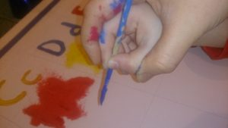
April 29-May 3, 2024
May: Water Safety Month
Mother Goose Day is May 1
Earth and Sky: Planet Patrol
Literacy | German/  ASL | Math | Science |  | Social Studies/Social Skills | Art | Music and  Movement | Small Group  Activities
Calendar and Weather  Letter R  Concept Words:  day, moon, night, sky, star, lightning, rain, storm, thunder, weather, wind, cold, fall, spring, summer, warm, water, planet, space, bottle, can, garbage, earth, paper, recycle. | German:  Song: “Weltraum-Maus”  ASL:  Colors that we know  Song | Review of Module 3 and 4 | How do our planets differ?  Sorting the colors of our planets |  | Land, Water and Air  How do we fight pollution?  Garbage clean-up experiment  Earth day social stories/  Kindergarten Prep Miss Cheryl’s class  Learning in Kindergarten | Monthly  Poem Art  Mother Goose  Art | Climb aboard the spaceship.  Solar System in Motion  Planet Song  Gravity Song | Cutting  Exercises  HWT  Individual  Reading
Poem:
Let’s go to sleep the little caterpillar said,
Before he tucked himself into his little bed.
He will awaken by and by,
And turn into a beautiful butterfly.

Books for this week:
Snowflakes, Sunbursts, and Stars by Ayako Brodek (GRP)
8 Spinning Planets: Brian James (GRP)
Astronaut: G. Carmichael (GRP)
There’s No Place Like Space: Tish Rabe (GRP)
Saturn : Gregory Vogt (GRP)
Space: Bendon (GRP)
See the inside of the Universe – Usborne (GRP)

