Garden Ridge Preschool
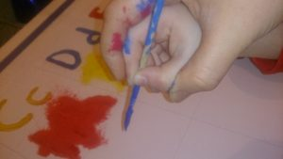
April 22-26, 2024
Earth and Sky: Seasons
Earth Day April 22, Arbor Day April 28
Literacy | German/  ASL | Math | Science |  | Social Studies/Social Skills | Art | Music and  Movement | Small Group  Activities
Calendar and Weather  Literacy: Review and Apply  (L,C,H,U)  Concept Words:  day, moon, night, sky, star, lightning, rain, storm, thunder, weather, wind, cold, fall, spring, summer, warm, water, planet, space, bottle, can, garbage, earth, paper, recycle. | German:  “Rund um das Jahr” Seasons.  ASL:  Colors that we know | Module 4-G  Comparison of sets including numerals up to 5 | The Cycle of the leaf.  Trees and soil. What happens to the soil when is cold? How do trees stay alive in the winter? Why do plants wake up in Spring? |  | Land, Water and Air  How do we fight pollution?  Garbage clean-up experiment  Earth day social stories  Friendship Skills:  Speaking Assertively | Arbor Day  Art | Vivaldi: Four Seasons Part 1  Spring Song  Springtime | Cutting  Exercises  HWT  Individual  Reading  Season Book
Poem:
The big round sun In an April sky,
Winked at a cloud that was passing by.
The gray cloud laughed as it scattered rain.
Then out came the big round sun again.

Books for this week:
Sun Snow Stars Sky by Catherine Anbolt (GRP)
Snowmen All Year by Caralyn Buehner (GRP)
Weeds Find a Way: Cindy Elliott (GRP)
Seasons by Jane York (GRP)
Oil Spill by Melvin Berger (GRP)
Farm by Elisha Cooper (GRP)
Miss Maple’s Seeds by Eliza Wheeler (GRP)

