Grade PK • Module 5 • Topics D–F

Family Math Newsletter

|  |
| --- |
| Key Standards   * Know number names and the count sequence. * Understand addition as *adding to,* and understand subtraction as *taking from*. * Understand simple patterns.   Looking Back  In the first half of Module 5, children learned to write numerals 0–5. They used actions, objects, and drawings to solve addition and subtraction stories.  Looking Ahead  In Kindergarten, children will begin the year building upon the sorting and classifying skills they learned in Pre-Kindergarten. They will count, write, and sequence numbers 0–10. |

Addition and Subtraction Stories and Counting to 20

In the second half of Module 5, students continue to tell and solve addition and subtraction stories with numbers 0–5, now using fingers, cubes, math drawings, or numerals to represent the number of units (e.g., puppies) in the stories. For example, children solve, “Three puppies are playing. One puppy stops to rest. How many puppies are still playing?” using their fingers, cubes, or drawings of circles (see Spotlight on Math Strategies). In the final lessons, children replicate and extend patterns focusing on the repeating part of the pattern.

Join us for the Children’s Math Theater to see our addition and subtraction stories come to life!

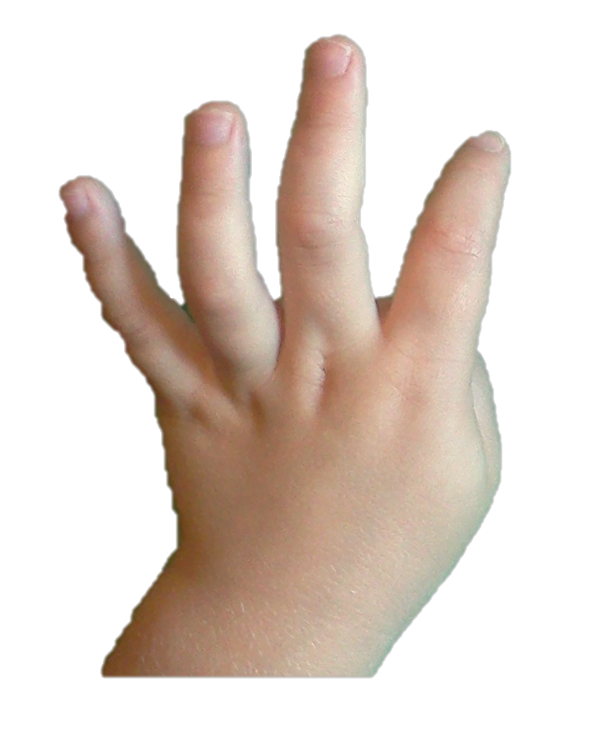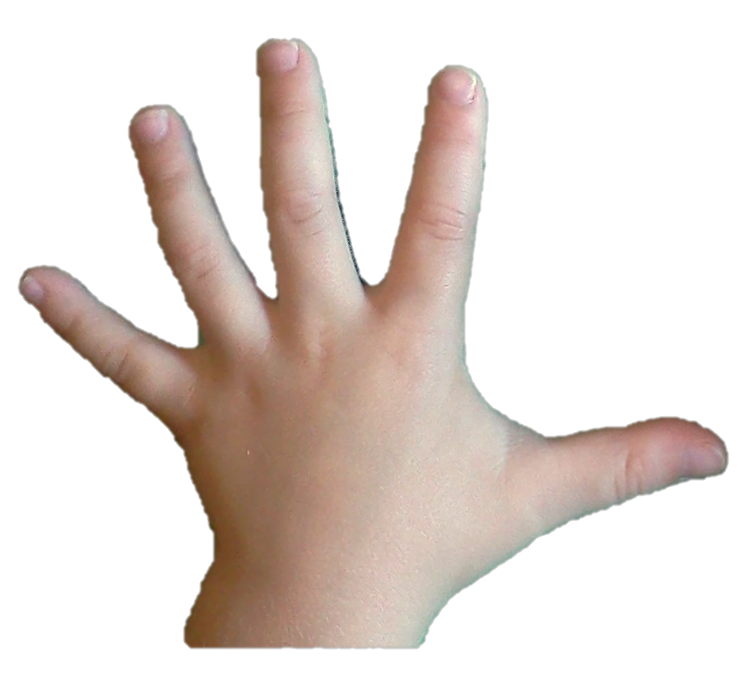

4 + 1 = 5

**SAVE THE DATE:**

Words and Key Terms

|  |  |
| --- | --- |
| |  | | --- | | * Add * Addition story * Altogether * Are left * Equals * In all * Math drawing * Number sentence * Pattern * Repeating part * Subtract * Subtraction story * Take away * Total | |

How to Help at Home

* Make up addition or subtraction stories during everyday experiences. While grocery shopping, say, “There are 3 apples in the bag already. Let’s put in 2 more. How many apples do we have now?” (This encourages your child to use his fingers to represent the story, since he can’t see the apples in the bag.)
* Look for patterns as you move through your community. Children will see patterns in buildings, fences, clothing, and art.
* Build varied patterns with your child whenever possible. This encourages spatial reasoning. For example, when serving dinner, put the components in a certain pattern, and then replicate that pattern on the other plates.

|  |  |
| --- | --- |
| Spotlight on Math Strategies  Drawings allow us to see mathematical situations and relationships in a way that helps make sense of the situation. The ability to represent a problem with a quick and abstract drawing will be key to children’s math success throughout elementary school and beyond. | |
| Sample Activity  (from Module 5 Lesson 25)  **Dribble and Pass**  Students count to 20 while practicing a fun pattern (dribble, pass, dribble, pass, …).    T: Let’s use a dribble and pass pattern with imaginary basketballs.  T: First we’ll dribble, and then we’ll pass. Then we’ll dribble, and then we’ll…?  S: Pass!  T: You’ve got it! Now, let’s count the Say Ten way as we dribble and pass.  T/S: 1 (dribble), 2 (pass),  3 (dribble), 4 (pass),  5 (dribble), ...  *In the lesson that follows, students learn to identify and duplicate patterns using objects.* | Focus on Tools: Math Drawings  Math drawings are different from the drawings children create for artistic expression. In an artistic drawing, children may focus on details, color, or the type of media used. Math drawings focus only on representing the situation efficiently so that children can make sense of the situation and find an accurate solution promptly.  The drawings on the right represent the following addition story: Four lizards are running. Another lizard starts to run. Now, how many lizards are running? The image at the top shows a time-consuming, detailed drawing of the lizards. Below that is a math drawing using circles to represent the lizards (notice that the original lizards are shaded circles, and the new lizard is an empty circle). Another math drawing uses the letter *L* to represent lizards. Children can use any of these drawings to solve the problem, but the last two drawings took less time and effort to create, allowing the focus to stay on solving the problem.  By comparing their drawings with those of other students, children learn to think flexibly: “How are our drawings the same? How are they not exactly the same? Did we come to the same answer?” They see many different perspectives and make connections between them. As they learn more problem-solving strategies in later grades, this flexible thinking helps them continue to see and understand multiple ways to solve a problem. |