Grade PK • Module 5 • Topics A–C
Family Math Newsletter
Addition and Subtraction Stories and Counting to 20
In the first half of Module 5, students write numerals 0–5 and count to 20. They explore addition and subtraction stories with numbers
0–5, a natural way for them to understand adding to and taking from. Stories are acted out, modeled with objects, drawn, or solved using pictures. Children ask and answer questions about the story, such as “How many in all?” or “How many are left?” They learn to distinguish the question from the story.

Key Standards
- Know number names and the count sequence.
- Understand addition as adding to, and understand subtraction as taking from.
- Understand simple patterns.
Looking Back
In Module 4, students compared length, weight, capacity, and numbers to 5. Students also counted to 15.
Looking Ahead
In Topics D–F of Module 5, students will explore addition and subtraction stories using fingers, objects, and drawings. Students will also work with simple patterns.

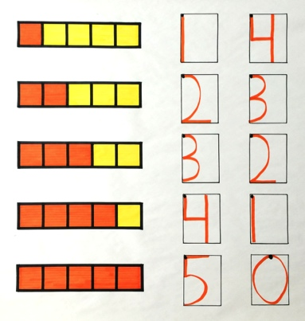
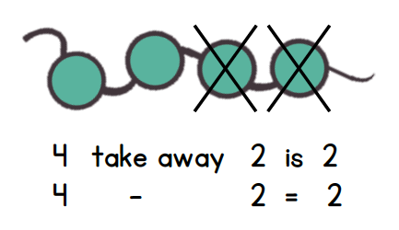
(Above) Children learn to write numerals 0–5.
(Below) Students cross off pictures to solve a subtraction story: There are 4 beads on the necklace. 2 beads come off. How many beads are left?

- Add
- Addition story
- Altogether
- Are left
- Equals
- In all
- Number sentence
- Plus
- Sixteen, seventeen, eighteen, nineteen, twenty
- Subtract
- Subtraction story
- Take away

How to Help at Home
- Make up addition or subtraction stories during everyday experiences. During bath time, say, “You have 3 toys in the tub. Here is 1 more toy. How many toys do you have now?”
- Work on a grocery list together. Have your child write the number of items needed, such as 5 apples, 2 boxes of cereal,
or 1 carton of milk.
- Ask for help with counting during everyday experiences. While cooking, say, “I need 10 tomatoes. Can you count out
10 tomatoes for me?”
- When reading any book, have your child touch and count the number of objects in pictures: “1, 2, 3, 4, 5, 6, 7. There are
7 dogs!”

Spotlight on Writing Numerals
Throughout the Pre-K year, children have learned to identify numerals and match them to a number of objects. Now, their fine motor skills have developed to the point where most children are ready to write. The standard in Pre-K is writing 0–5, advancing to writing numerals 6–20 in Kindergarten.
Number Formation Chants  Simple rhymes help children remember how to write each numeral. Some children will say the rhyme each time they write until the strokes become automatic.  Curve from the top;  be a hero!  Close the loop, and  make a zero.  Top to bottom,  then I’m done.  I just wrote  the number 1.  Half a moon,  there’s more to do;  slide to the right,  I wrote a 2.  Backward C,  backward C,  that is how  I write a 3.  Down the side,  to the right some more.  Top to bottom,  I’ve written 4.  Down the side,  around a hive.  Give it a hat.  I’ve written 5. | Focus on Tools: The Writing Rectangle  The writing rectangle is a tool to help children write numerals systematically, to make handwriting easier for them in the future. Writing rectangles use a dot to show where to start the numeral. If children start from the dot and keep the numeral inside the rectangle, they will not reverse their numbers as readily (i.e., write them backward).  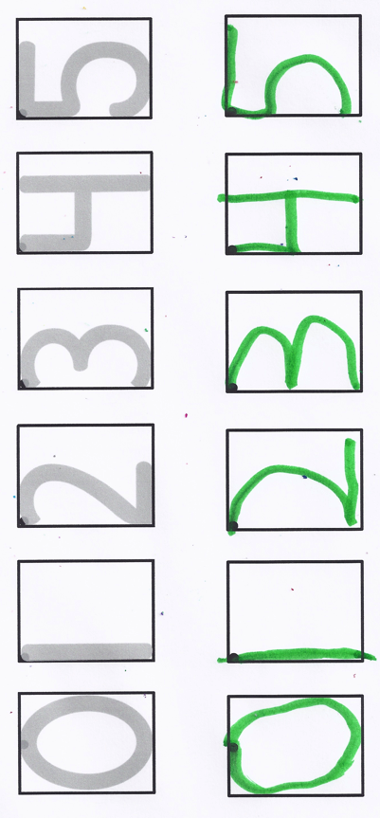  Starting numbers and letters from the top is an important habit for your child to learn now. It will help her keep up when the writing demands increase in later grades. Numerals 1–5 all begin at the top left, with 0 starting in the center of the top side of the rectangle.  For some adults, it seems odd to start the 5 in the left corner and add a hat at the end. When in doubt, if children start at the left corner, they will be in the correct place for 7 out of 10 numerals (0, 8, and 9 are the exceptions). Starting the 5 at the left corner reinforces this idea.  At first, children will trace the numbers inside the writing rectangle with and without a writing instrument and then write them without tracing. Students do eventually write numerals 0–5 without the writing rectangle, but this tool provides them with a structure to form numerals correctly from the start.

