Grade PK • Module 1 • Topics E–H
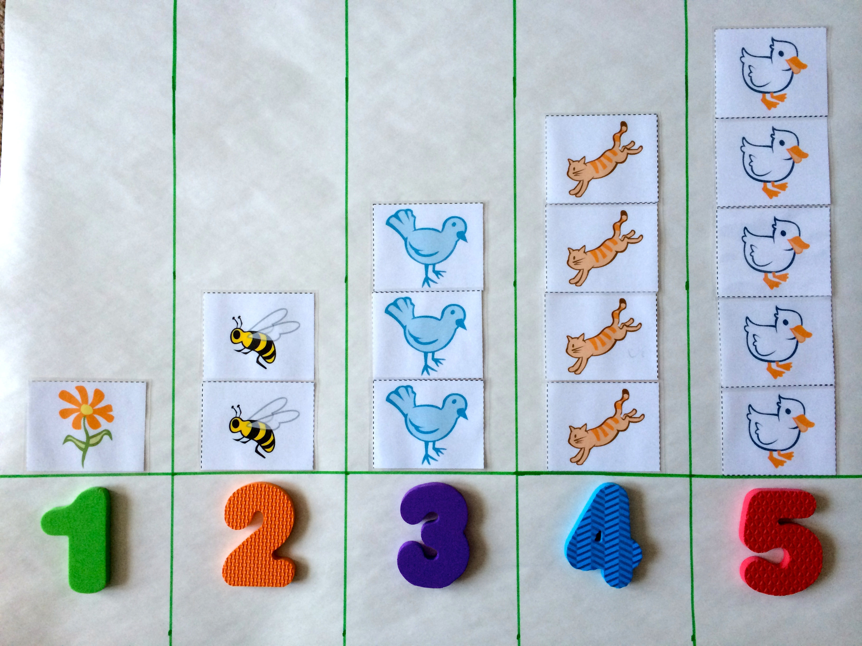

Family Math Newsletter
We will count the number of people in our families. Please send a photograph of your family for our project.
4
Key Standards
- Know number names and the count sequence.
- Count to tell the number of objects.
- Understand that each successive number name refers to a quantity that is 1 larger.
Looking Back
We learned to sort and practiced touching and counting groups of up to three objects.
Looking Ahead
In Module 2, children identify, describe, and build shapes.

Numbers to 5
In the second half of Module 1, children touch and count groups of up to five objects arranged in different ways. They learn to match their count to a numeral 1–5. Children also see patterns in the counting sequence. When counting forward, they see each number is 1 more: One. One more is 2. Two. One more is 3.


Words and Key Terms

REMINDER: Send in by _________
Vocabulary
- After
- Count
- Group
- Line
- Number
- Sort
New Terminology
- 1 more
- 1 less
- The Math Way (count on fingers from left pinky to right pinky)
- How many?
- Mark (show start of counting path)

How to Help at Home
- Touch and count up to five objects together. At snack time, say, “1, 2, 3, 4, 5. You have 5 crackers.” Move the crackers into a line or a circle and count again.
- Buy or make a set of numerals 1–5 (paper, foam, or magnets work well). When getting dressed, ask, “Which number shows how many shoes you are wearing?”
- Point out and name numerals in everyday experiences. While riding an elevator, ask, “Which button has the number 4?”
- Sing songs that involve counting forward or back, such as “The Ants Go Marching,” “This Old Man,” “Five Little Ducks Went Out to Play,” or “Five Little Monkeys Jumping on the Bed.”

Spotlight on Math Models
A Story of Units has key mathematical models that are used throughout a student’s elementary years. One of these models is the number stair, a tool students use to model the patterns of 1 more and 1 less in the count sequence.
Sample Song  (from Module 1, Lesson 29)  The Ants Go Marching  The ants go marching 1 by 1.  Hoorah! Hoorah!  The ants go marching 1 by 1.  Hoorah! Hoorah!  The ants go marching 1 by 1;  The little one stops to suck his thumb,  And they all go marching down, to the ground,  To get out of the rain.  BOOM! BOOM! BOOM!  Repeat with numbers 2–5:  2…tie a shoe  3…climb a tree  4…shut the door  5…take a dive  By participating in a story situation in which ants join the group one by one, students begin to experience a growth pattern, or a pattern of 1 more, in a fun way. | Number Stairs  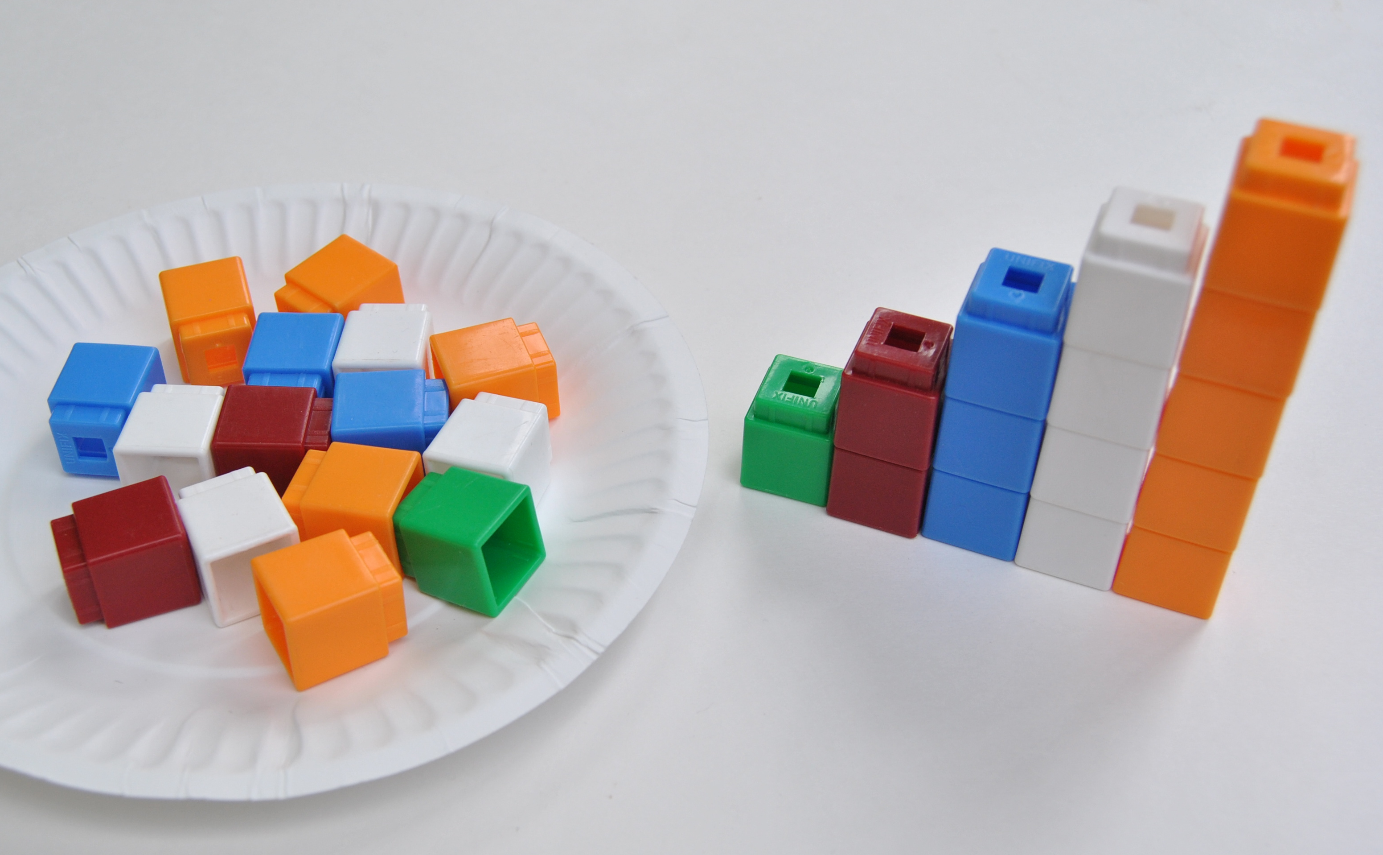  Students have already used number towers (joined linking cubes) to work with numbers 1 to 5. At the end of Module 1, children create number towers for numbers 1 to 5 and place them in order to create number stairs.  Number stairs make it easy for children to see that each successive number in the count sequence is 1 more: “One. One more is 2. Two. One more is 3….” Conversely, as they count back from 5 (5, 4, 3, 2, 1) children see the 1 less pattern represented in the number stairs.  This understanding sets the stage for children to understand adding 1 and subtracting 1, which they will begin to explore at the end of the year. It is also a prerequisite skill for the counting on strategies used in Grade 1.

